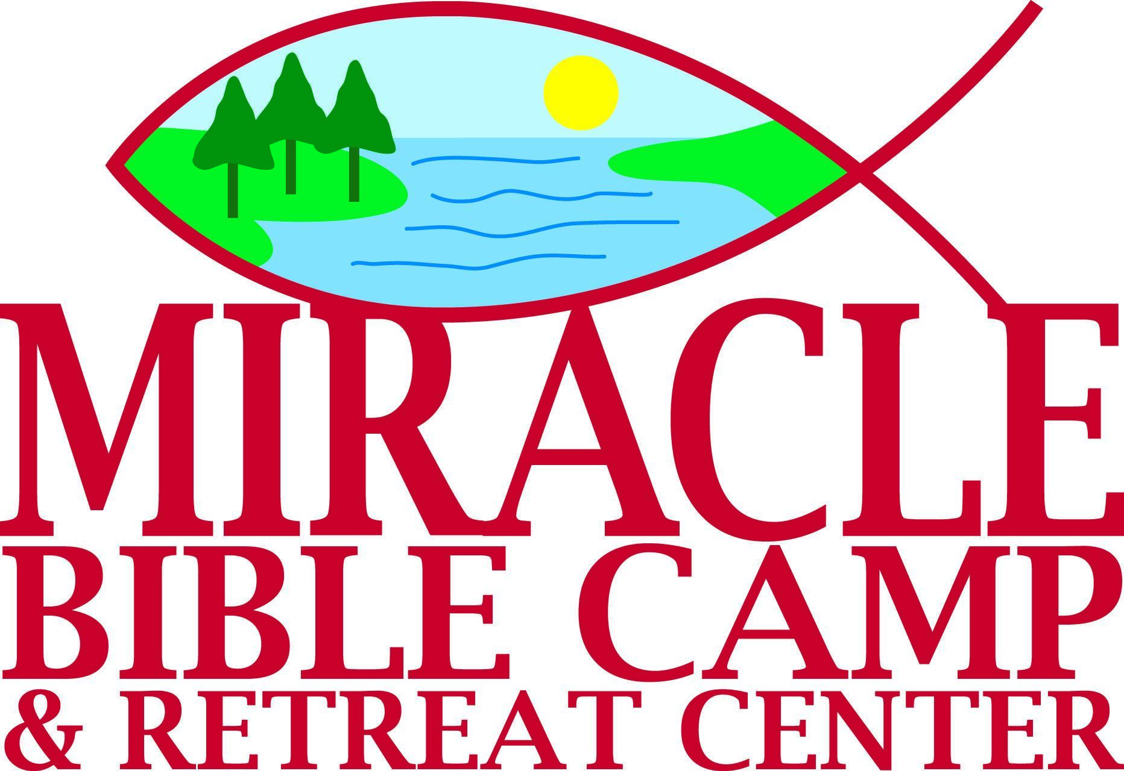
Fall Frenzy Registration
To register on-line go to www.miraclebible.com
CAMPER INFO
Last Name ______________________________________ First Name ______________________________________________

Grade __________ Birth Date _____ /_____ /_____ _____ Male _____ Female

Roommate Request ________________________________________________________________________________________
PARENT/GUARDIAN INFO

Name ____________________________________________________________________________________________________
Address __________________________________________ City _______________________ State ______ Zip ___________
Best Contact Email __________________________________________________________________________________________
Best Contact Phone ( ) ______________________
Home Church _______________________________________________________________________________________________
ALTERNATIVE CONTACT INFO
Note: List additional person who may be able to help us reach parent or guardian.
Name _____________________________________________________________________________________________________
Phone ( ) _____________________
Relationship to Camper ________________________________________________________________________________________
DIETARY NEEDS
___ None ___ Gluten-Free ___ Dairy-Free Other: ___________________________________________
MEDICAL CARE
Primary Health Care Provider (Clinic or Health System) _______________________________________________________________
Health Insurance Company _____________________________________ Policy Number ___________________________________
Medication Allergies ___________________________________________________________________________________________
Most Recent DTP/Tetanus Vaccine (date or exempt) __________________________________________________________________
Most Recent MMR Vaccine (date or exempt) _______________________________________________________________________
HEALTH INFORMATION
Are there any allergies other than to food or medication? (Ex: Bee stings, has Epi-pen) ______________________________________
____________________________________________________________________________________________________________
Are there any other health concerns that camp staff should be aware of? ________________________________________________
____________________________________________________________________________________________________________
May the camp staff give ibuprofen, acetaminophen, calamine lotion or antibiotic ointment as needed? ____ Yes ____ No

MEDICATIONS
Please list medications you are planning to send to camp: _____________________________________________________________
____________________________________________________________________________________________________________
____________________________________________________________________________________________________________
PHOTOS & VIDEOS
I authorize Miracle Bible Camp to use photos, videos, and statements for promotional purposes. ____ Yes ____ No
LIABILITY RELEASE
- I certify that my child is in good health and does not need a medical physical to participate in all camp activities. I agree to inform camp staff of any medical conditions or special needs prior to the start of camp.
- I authorize camp staff to provide first aid and/or seek emergency medical treatment for my child if necessary and understand that I am responsible for any associated costs.
- I release Miracle Bible Camp, its staff and volunteer workers from any liability or claims which may arise related to my child's participation in programs or trips sponsored by Miracle Bible Camp.

Parent/Guardian Signature ______________________________________________________________ Date: __________________

PAYMENT INFO
NOTE: A $50 min. deposit must accompany this form. Financial aid is available by request for those who need assistance to attend camp. Please make your request on the registration form below or by email.

The cost for the Fall Frenzy Retreat is $120.
Do you need financial assistance?
____ No
____ Yes, a 50% discount is needed.

Please include a check for the $50 deposit (or for the full price of the retreat) with this registration form.
Mail this form and payment to Miracle Bible Camp 4389 Timber Dr NW Hackensack MN 56452
admin@miraclebible.com www.miraclebible.com

